Day of Pentecost
The Tomorrow River Lutheran Parish
May 24, 2026
We welcome visitors into our community! May you be blessed as you join us in Worship!

GATHERING

WELCOME AND ANNOUNCEMENTS

* OPENING PRAYER

∗ HYMN God of Tempest, God of Whirlwind #400

* THANKSGIVING FOR BAPTISM
All may make the sign of the cross, the sign that is marked at baptism, as the presiding minister begins.
Pastor: Alleluia! Christ is risen.
All: Christ is risen indeed. Alleluia!

Pastor: Salvation belongs to our God who is seated on the throne
and to the Lamb!
All: Amen.
Pastor: Let us give thanks for the gifts of baptism.
Water may be poured into the font as the presiding minister continues.
Pastor: Merciful God, you are the one who was, who is, and who is to come. You lead us beside still waters. We thank you for the waters of creation: morning dew, gentle rain, roaring waves.
We thank you for the waters that nourish us. Blessed are you.
All: You guide us to springs of the water of life.

Pastor: Jesus Christ, you are the faithful witness who accompanies us on our journeys. We give you thanks for your life-giving death and resurrection. We praise you for joining us in joy and sorrow. Blessed are you.
All: You guide us to springs of the water of life.

Pastor: Holy Spirit, you anoint our head with oil and our cup overflows. Break down barriers that divide us. Fill us with the breath of peace. Blessed are you.
All: You guide us to springs of the water of life.

Pastor: Holy One, we thank you for the gifts and grace of baptism,
and for making us a new creation. We join with saints and angels, giving you honor and praise, now and forever.
All: Amen.

CHILDRENS SERMON

* PRAYER OF THE DAY
All: O God, on this day you open the hearts of your faithful people by sending into us your Holy Spirit. Direct us by the light of that Spirit, that we may have a right judgment in all things and rejoice at all times in your peace, through Jesus Christ, your Son and our Lord, who lives and reigns with you and the Holy Spirit, one God, now and forever.
Amen.
WORD

* GOSPEL John 20:19-23

¹⁹ When it was evening on that day, the first day of the week, and the doors were locked where the disciples were, for fear of the Jews, Jesus came and stood among them and said, “Peace be with you.” ²⁰ After he said this, he showed them his hands and his side. Then the disciples rejoiced when they saw the Lord. ²¹ Jesus said to them again, “Peace be with you. As the Father has sent me, so I send you.” ²² When he had said this, he breathed on them and said to them, “Receive the Holy Spirit. ²³ If you forgive the sins of any, they are forgiven them; if you retain the sins of any, they are retained.”

Pastor: This is the Gospel of the Lord.
All: Thanks be to God.

SERMON Pastor Anderson

* HYMN OF THE DAY Loving Spirit #397

* THE APOSTLES’ CREED
All: I believe in God, the Father almighty, creator of heaven and earth. I believe in Jesus Christ, God’s only Son, our Lord, who was conceived by the Holy Spirit, born of the virgin Mary, suffered under Pontius Pilate, was crucified, died and was buried; he descended into hell. On the third day he rose again; he ascended into heaven, he is seated at the right hand of the Father, and he will come to judge the living and the dead. I believe in the Holy Spirit, the holy catholic Church, the communion of saints, the forgiveness of sins, the resurrection of the body, and the life everlasting. Amen.

* PRAYERS OF INTERCESSION
Pastor: …Lord, in your mercy ...
Congregation: Hear our prayer.

* THE LORD’S PRAYER
All: Our Father who art in heaven, hallowed be thy name, thy kingdom come, thy will be done, on earth as it is in heaven. Give us this day our daily bread; and forgive us our trespasses, as we forgive those who trespass against us; and lead us not into temptation but deliver us from evil. For thine is the kingdom, and the power, and the glory, forever and ever. Amen.

* BLESSING

WE WELCOME OUR VISITORS AND WE’RE SO GLAD YOU CAME TO WORSHIP WITH US TODAY!

Contact us at 715-824-5615 or
Email: trchurch@gmail.com
For more information please visit www.trchurch.org
Our website is full of information about our churches and services.


Tomorrow River Lutheran Parish – One Parish, Two Great Churches!

Nelsonville Evangelical Lutheran Church
3061 Oak Street, Nelsonville, WI 54458


Peace Lutheran Church
293 South Main Street, Amherst, WI 54406

Our Church Office is located inside Peace Lutheran Church

Office Hours
Monday: 8:15am to 1:00pm
Tuesday: 8:15am to 1:00pm
Wednesday: CLOSED
Thursday: 8:15am to 1:00pm
Friday: 8:15am to 1:00pm

For those who wish to give with a credit or debit card or via EFT from your bank account, please use this QR Code.


Thank you for your faith filled support for the ministries of the church!
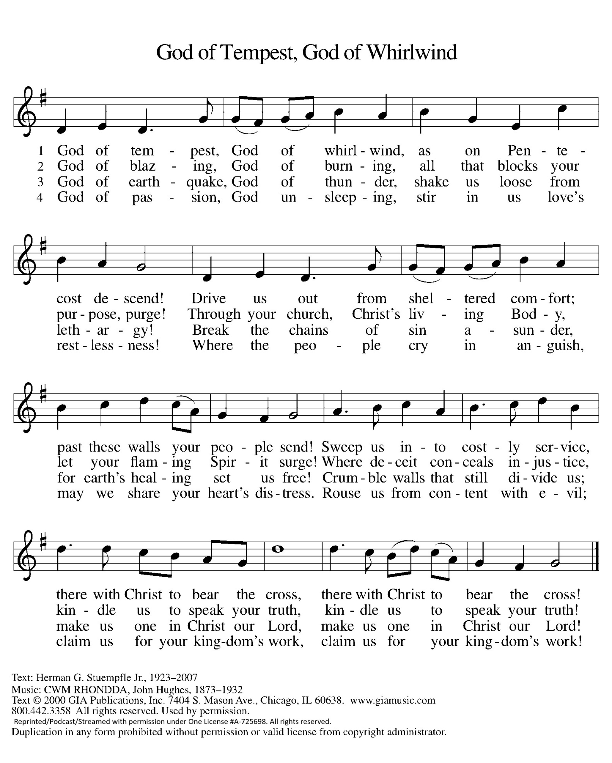

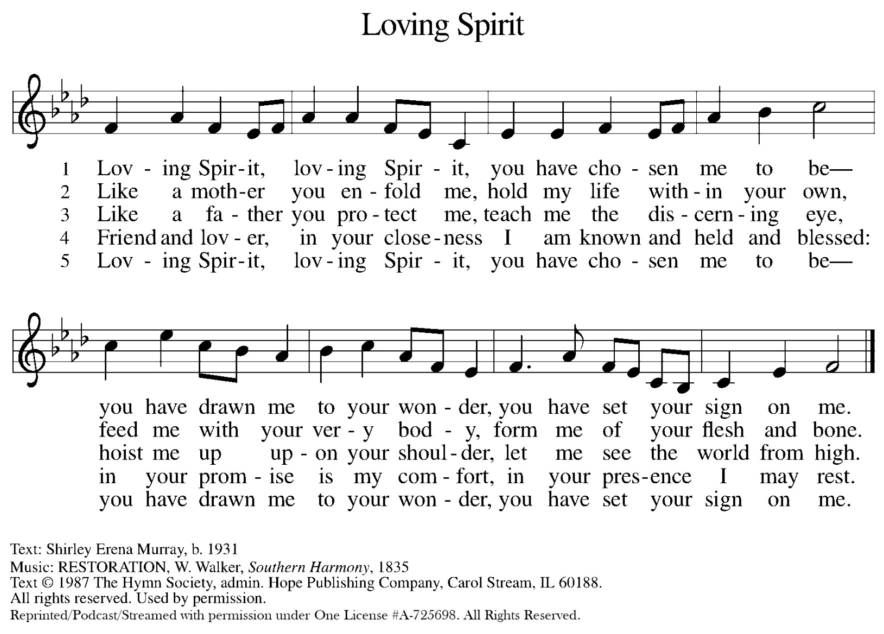



The
Messenger

The weekly newsletter of the Tomorrow River Lutheran Parish. Pretty much everything you need to know... Guaranteed mostly reliable! And it’s free!

Calendar for May 24 to May 31

Sun. May 24 | Worship Service (AM) Senior Sunday | 8:30am
 | Worship Service (NV) Senior Sunday | 10:15am
 | Live Stream Worship Service (trchurch.org) | 10:15am
Mon. May 25 | Memorial Day
Tues. May 26 | LWR Quilting (NV) | 9:00am
 | AA Meeting (AM) | 10:30am
Wed. May 27 | Do Group (AM) | 12:30pm
Thurs. May 28 | TRACK Food Pantry (AM) | 5:00pm
Sun. May 31 | Worship Service (AM) Senior Sunday | 8:30am
 | Worship Service (NV) Senior Sunday | 10:15am
 | Live Stream Worship Service (trchurch.org) | 10:15am

Happy May Birthdays to Our Senior Members!
Anita Oltmann 5/2 Sue Bouck 5/4
Jan Konkol 5/11 Bob Lea 5/13
Marlene Sannes 5/26


Hearing devices are available for those in need, on the information counter. For those with hearing aids, please turn on your telecoil.

If you would like to talk to a council member about an idea or concern,
call or email the church office and we will put you in touch.
Interested in joining the Tomorrow River Parish?
Please contact the parish office: trchurch@gmail.com or 715-824-5615
More information is available on our website: www.trchurch.org

Nelsonville May Greeters: Bob and Donna Havemann

PARISH ANNOUNCEMENTS

Lutheran World Relief Personal Care Kits. When a disaster hits a community the very simple gesture of giving a Personal Care Kit can give someone the encouragement they need. Please donate new items, bath-size soap, adult size toothbrush (multi-packs accepted), sturdy comb, metal nail clipper, light-weight bath towel, dark color recommended (between 20” x 40” minimum and 27” x 52” maximum). Monetary gifts are welcome if you don’t like to shop—we will shop for you. In 2025, Nelsonville Church sent 213 Personal Care Kits to LWR! Thank-you! Example of kit items can be viewed in the Narthex.

Bible Camp Scholarship Opportunities: Nelsonville members, please consider sending your child to Bible Camp. Scholarship covers one-half of early registration fee. Contact the church office for more information.

If you know how to knit or crochet and you have a little spare time, can you make some baby sweaters for the Baby Care Kits? Patterns are available at the church office and online at trchurch.org, under LWR. Or call and we’ll send them to you.

Time on your hands? Become an artist. Don’t pick up a brush or paint, instead pick up needles, thread, and material. Become a Peace Quilter. Quilt Kits are available in the fireside room every Sunday at Peace during Social Sunday. Create . . . a Quilt!

TRACK Food Pantry – TRACK (Tomorrow River Area Community Kitchen) provides food for families with needs in the Tomorrow River School District area. Hours: Monday 8:00 to 10:00 am and Thursday 5:00 to 7:00 pm at Peace. Donations can be dropped off during church service at either church, or during office hours at Peace: M, T, Th, F 8:15 am —1pm

DAILY LECTIONARY for May 24 – May 31

Sun May 24 – Numbers 11:24-30 Psalm 104:24-34, 35b 1 Corinthians 12:3b-13 or Acts 2:1-21 John 20:19-23 or John 7:37-39
Mon – May 25 - Joel 2:18-29 Romans 8:18-24 Psalm 104:24-34,35b
Tue – May 26 - Ezekiel 39:7-8, 21-29 Romans 8:26-27 Psalm 104:24-34,35b
Wed – May 27 - Numbers 11:24-30 John 7:37-39 Psalm 104:24-34,35B
Thu – May 28 - Job 38:1-11 2 Timothy 1:8-12a Psalm 8
Fri – May 29 - Job 38:12-21 2 Timothy 1:12b-14 Psalm 8
Sat – May 30 - Job 38:22-38 John 14:15-17 Psalm 8
Sun May 31 – The Holy Trinity First Sunday After Pentecost Readings Genesis 1:1–2:4a Psalm 8 (1) 2 Corinthians 13:11-13 Matthew 28:16-20

(Updated 5/12/26)

Baby Theo, child of Cray and Morgan
Sunny P. in the hospital recovering from a fall
Carrie M. in hospice (Mother of Becky M-B)
Carol, recovering from a gunshot wound
A Young Couple, with children, who have lost their faith in God
A Man recovering from a bicycle-car accident
A couple wanting to adopt
A woman with a tumor on her brain stem
Carlos, AHS Graduate as he resettles in Nicaragua
Chuck Q., recovering from stroke (brother of Mert W.)
John P. Stage 4 Sarcoma Cancer, undergoing Chemo Therapy (Son of Tom and Peggy)
Mary W. Recovering in Rehab (Sister of Tim P)
Marilyn, pea-size brain tumor (friend of Pam B.)
Steve S., recovering from hospitalization (Diana B.'s brother)
Two men recovering from kidney transplants
Joyce, diagnosed with cancer (Cathi W.'s friend)
Stacey, multiple devastating health issues (Cathi W.'s niece)
Sabrina, a baby with severe congestive heart failure, waiting for new heart (friends of Mark & Lisa C.)
Tom S., additional treatment
Patty H., in palliative care (Lynda S.'s sister)
Sandi, diagnosed with cancer (friend of Lynette G.)
Betsy and Al S., prayers for healing (friends of Dean & Gloria O.)
Russ, auto-immune disease, on liver transplant list (Cindy R.'s nephew)
Jen K., suffering from vertigo and migraine (Lynda S.'s daughter)
A young couple dealing with fertility issues
A woman in stage 4 renal failure
Rebecca, prayers for health and healing
Young people dealing with addictions and mental health issues
For the innocents in Ukraine, Israel, Gaza, Lebanon, Iran & the surrounding countries
For the Rulers of the Nations: That they may be wise and good
That God would Humble the Aggressor, Strengthen the Righteous, Protect the Innocent and Help us to find a Just Peace
Members of our military and their families, as they continue to serve
Our members with limited mobility and those who are homebound
Our companion congregations at Chaneng and Silkatskop in South Africa
Members of our councils, as they make critical decisions regarding the ministries of the Church

We pray for those who have asked to be on our prayer list and only publish names when given explicit permission. We will keep people on the prayer list for up to six weeks unless specifically asked to keep them on longer. If you are aware of any changes that need to be addressed on the prayer list, please contact the church office. Thank you.

